CMPS350 Web Development

E-Commerce Platform

1. QUID: 201805167 STUDENT NAME: Shama Al Ahmed Effort given: 33.3%
2. QUID: 202002679 STUDENT NAME: Fatima Saleh Effort given: 33.3%
3. QUID: 201804370 STUDENT NAME: Anfal Ahmed Effort given: 33.3%

CMPS350 Web Development – Spring 2024

Sections: L52

Submitted: 30th March 2024

Submitted to: Dr. Mucahid Kutlu

**• DECLARATION:** We hereby certify that no part of this project or product has been copied from any other student’s work or from any other sources except where due acknowledgement is made in the project. No part of this project/product has been written/produced for us by any other persons.

* **Introduction**

The E-commerce platform projects it is designed to allows a customer to purchase items and the seller to sell items. This report outlines the key aspects of the platform is implementing the html for page content and structure, CSS for styling the page, and the JavaScript for interaction.

**Github link:**

https://github.com/anfal-aa1804370/Web-project

1. **Application Design Documentation:**

**Repositories class diagram:**

|  |  |  |  |  |
| --- | --- | --- | --- | --- |
| UserRepo |  | ProductRepo | OrderRepo |  |
| Login(username,password) |  | deserializeProducts(products):  products[] | getOrders():orders[] |  |
| getUser(id: int): User |  | getProducts() | addOrder(order) |  |
| updateMoney(id, amount, type) |  | setProductsLS(products) |  |  |
| updateCurrentUser() |  | getProductsLS(): products[] |  |  |
|  |  | ddProduct(product) |  |  |
|  | updateProduct(name, stock) |  |  |
|  | sellProduct(name, quantity) |  |  |

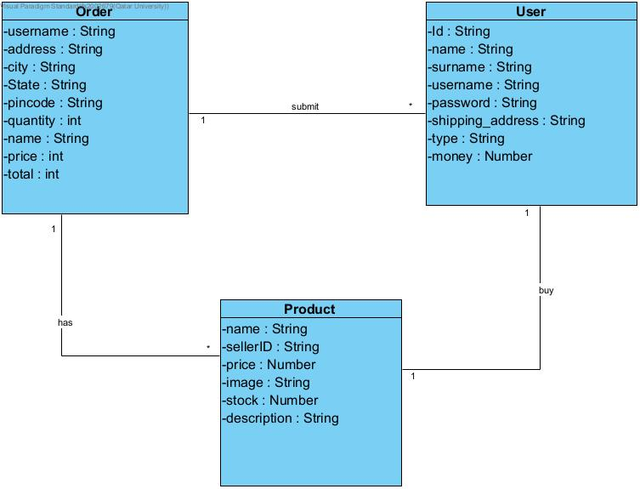

1. **Video show the e-commerce platform.**





1. **Document App Testing using screenshots.**

**Use case 1:**

* 1. Show that when a user cannot log in if the password and username does not match.

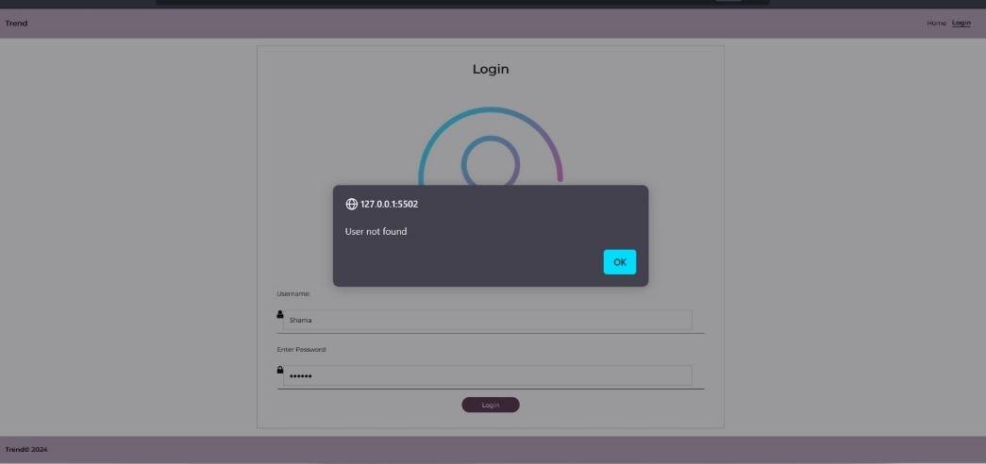

The username & passwords it is not match with the user in the json file so it will show an alert that the user is not found.

* 1. Show that a user as a customer successfully logs in

When the user is verified by the username and the password it will successfully login to the main page of the customer application.

* 1. Show that a user as a seller successfully logs in

When the user is verified by the username and the password it will successfully login to the main page of the seller application.

**Use case 2:**

1. Do a search in which there is no available item

When the user is searching for an item that is not in the e-commerce platform it will not appear for him.

1. Do a search in which there are some available items.

When the user is searching for an item that is available within the platform it will display for him.

1. Do another search in which there are some available items.

When the user is searching for an items that is available within the platform it will display for him.

**Use case 3 and Use case 4:**

1. Try to purchase an item when you are not logged in (it should fail)

The platform will not allow a user to buy if he is not logged in to the platform as a customer.

1. Try to purchase an expensive item that the user does not have enough money (it should fail)

When the customer wants to purchase an item that is beyond his money balance in the bank account it will not allow him and will display an alert that there is insufficient funds.

1. Purchase an item successfully

Whenever the customer wants to purchase an item in the platform it will allow him to purchase. Only if he doesn’t have enough money, he will not allow him.

1. Go to the purchase history and show that item has been bought.

When the customer purchases an item. He will be able to see his order in the order list.

**Use case 5 and Use case 6:**

1. Upload an item to be sold

The seller will be able to add an item to the platform whenever he wants.

1. Show that the uploaded item is now searchable

When the seller adds an item, it will be available to search for it.

1. Show that the uploaded item is on available item lists

When the seller adds an item, the item will displayed in the list.

1. Show that when an item is sold, its quantity decreases.

When the customer purchased an item the platform automatically will decreased the item stock.

Seller can update the stock of the items.